}

Guide 1. APT Project Definition
Capstone Course

- PART I
1. Personal Background
Below is a table for you to fill in with the requested information.

Student Name | Nicolas Carmona  Rosa Garrido  Mateo Alvares
RUT | 20.325.328-1  21.622.466-3  20.880.073-6
Degree Program | Computer Engineering
Campus | Duoc UC Melipilla

2. APT Project Description
In the description, briefly state the name of your APT project and the graduate profile competencies you will put into practice. If performance areas are defined in your degree program, also mention which performance areas the project is linked to.

Project Name | Haircut Home Studio
Performance Area(s) | The Haircut Home Studio project spans part of the analysis and requirements gathering, reflected in the requirements spreadsheet and the project summary that define the scope and business rules, organized as a Product Backlog before starting the sprints; it continues with software design and development, materialized in the mockups that will be converted into .php files with the booking, login, and client/administrator flow logic, built incrementally in each sprint; it includes database modeling and development, through the design of tables for users, bookings, services, availability, and the status of each request; it requires environment and service administration, by configuring the PHP environment, the database, and the web server so the system runs continuously; it involves software quality assurance, through form validations and status control to prevent double bookings, verified at the close of each sprint; it considers computer systems security, with user authentication, session management, and protection of administrator routes; and finally it involves agile management of IT projects, applying Scrum to organize the work into sprints, prioritize the backlog, and track progress through daily meetings and periodic reviews.
Competencies | - Administer the configuration of environments, application services, and databases in an enterprise environment, to enable operability and ensure the continuity of the booking system.  - Offer IT solution proposals, comprehensively analyzing the hair salon's processes according to its requirements.  - Develop a software solution using agile techniques (Scrum) that allow the development and maintenance process to be systematized, ensuring the achievement of objectives per sprint.  - Build data models to support the system's requirements (users, bookings, services, availability), with a design that is scalable over time.  - Offer IT solution proposals comprehensively analyzing the processes according to the organization's requirements.  - Develop a software solution using techniques that allow the development and maintenance process to be systematized, ensuring the achievement of the objectives.  - Build data models to support the organization's requirements according to a defined design that is scalable over time.  - Program queries or routines to manipulate database information according to the organization's requirements.  - Build programs and routines of varying complexity to solve the organization's requirements, in line with market technologies and using good coding practices.  - Perform certification tests on both products and processes using good practices defined by the industry.  - Build the architectural model of a systemic solution that supports business processes according to the organization's requirements and industry standards.  - Implement comprehensive systemic solutions to automate or optimize business processes according to the organization's needs.  - Resolve systemic vulnerabilities to ensure that the software built complies with the security standards required by the industry.  - Manage IT projects, offering alternatives for decision-making according to the organization's requirements.

3. APT Project Rationale
Below are different fields that you must complete with the requested information. This section seeks for you to describe your project in detail and justify its relevance and pertinence.

Relevance of the APT Project | HairCut Home Studio was born out of a real need: the owner of this hair salon schedules his appointments manually via WhatsApp and phone calls, which takes up his time, creates a risk of double bookings, and leaves him without an organized record of his work.  The project proposes a web platform that automates and centralizes scheduling, freeing up his time and organizing the business. This is a relevant topic for the professional field because it applies key competencies from the degree program (requirements, software development, databases, and agile management with Scrum) to a problem that cuts across many service industries, not just hair salons.  It is set in the context of a small business located on Psje Prof. Ricardo Luengo Mardones, Melipilla, Metropolitan Region, with no budget for business management software, and it impacts both the owner and his clients, who will be able to book from their phone without calling or texting. Its value contribution is concrete: it saves time, reduces scheduling errors, and improves the booking experience, thereby validating its professional and social relevance beyond the academic context.
APT Project Description | This system is expected to allow the hair salon's schedule to be managed, recommending or allowing clients themselves to select the available time slot that suits them best by using an account in the system, in addition to being able to review haircuts and treatments that are common for each client's hair type.  We plan to address the problem by automating the entire process and making it simpler, moving everything that is currently done manually onto a digital platform, reducing complexity and saving time by doing so, as well as keeping a record of everything that is done, which currently does not exist.
Relevance of the Project to the Graduate Profile | Haircut Home Studio relates to the graduate profile because its development follows the same cycle that the profile requires of a Computer Engineer: analyzing a real organizational problem, designing a technological solution, implementing it, and ensuring its quality. The selected competencies are necessary because each one solves a specific part of the problem: analyzing the hair salon's processes makes it possible to offer a solution that responds to its reality rather than simply transferring it to another format; developing the software using agile techniques (Scrum) allows the system to be built in an organized way and through functional increments; correctly modeling the data avoids precisely the errors the project seeks to eliminate, such as double booking; and administering the environment and services ensures that the platform is available whenever the client needs to book. Together, these competencies reflect what the graduate profile seeks to certify: the ability to take a real organizational need through to a functional and sustainable technological solution.
Relationship with Professional Interests | Explain how the APT Project you propose relates to your professional interests.  What are your professional interests? Which aspects of your professional interests are reflected in your APT Project? How will carrying out this APT Project contribute to your professional development?  Our professional interests focus on building and developing technology projects from scratch, building complete web applications, and delving into artificial intelligence development, which relates directly to data science. In addition, we are interested in working with technologies not used during the degree program and applying agile methodologies such as Scrum to move forward in an organized way, deliver concrete progress step by step, and adapt easily to changes.  The project presented contributes to our professional development because we apply everything learned during the degree program, in addition to integrating outside knowledge, which is essential in our field since we have to learn new things every day. It also puts us to the test in a real-world context, in which, if we are able to develop a solution for a specific client, it gives us an extra edge for our development as professionals — being able to improve someone's life through technology is our greatest aspiration through this work.
Feasibility of Developing the APT Project | We consider it possible to develop Haircut Home Studio within the semester timeframe because it is a system with a limited, well-defined scope: a client module (catalog, login, bookings, history) and an administrator module (availability, requests, reports), already defined beforehand in the requirements spreadsheet and the mockups, which avoids rework at the design stage and allows us to focus the course hours directly on programming. By working with Scrum, we divide the development into short sprints with functional deliverables, which makes it easier to adjust the pace of progress to the length of the semester and the weekly hours assigned to the course, prioritizing the critical functionalities first (authentication and time-slot booking) and leaving the less urgent ones (reports, AI preview) for later sprints.  In terms of materials, the project does not require costly infrastructure: a temporary local development environment (PHP, an Apache/Nginx server, and a MySQL/MariaDB database, for example via XAMPP or similar), a code editor, and, for final testing, basic hosting or a free service that supports PHP, are all that is needed. The entire technology stack is open source and extensively documented, which reduces the learning curve and technical risk.  As external factors that facilitate development, we have direct access to the real end user (the salon owner), which allows us to validate requirements and receive feedback throughout the process instead of working solely on assumptions. As factors that could hinder development, we identify the real client's time availability to provide timely feedback and the simultaneous academic workload of other courses during the semester; to mitigate this, we plan brief, spaced-out meetings with the end user, and we use Scrum's prioritized backlog to ensure that, even if the schedule is tight, the project's essential functionalities are completed before the secondary ones.

- PART II
4. Objectives
In this section you must define general and specific objectives for the APT Project. It is important to clarify that objectives should be stated clearly, concisely, and without further explanation — that is, they should be self-explanatory. It is suggested that you write them using a verb in the infinitive, since this forces you to specify concrete actions.

General Objective | Develop a web platform for Haircut Home Studio that automates the scheduling of appointment times and incorporates an intelligent block-assignment engine, in order to reduce the professional's manual management time and increase the utilization of his workday.
Specific Objectives | - Gather and document the current scheduling process through interviews with the client, identifying operational inefficiencies.  - Design the platform’s architecture and data model, taking into account the business constraints: a single professional, two workstations, services of variable duration, and at-home service.  - Implement the client management, booking, and administration modules applying Scrum in two-week sprints, with incremental functional deliverables.  - Develop and evaluate the agent component, comparing its performance against the current manual method using occupancy metrics.  - Validate the solution through a period of real-world use by the client, comparing the results against the defined success criteria.

5. Methodology
In the following section you must describe the methodology, specific to your discipline, that you will use to carry out the APT project described above, including the stages and working methods.

Methodology Description
We will use an agile methodology, specifically SCRUM + Kanban, to develop the project, given the uncertainty regarding the hair salon's requirements. It will be organized as follows.

Phase 1: 3 weeks
Weeks 1 and 2: First contact with the client + presenting the project vision + Definition of Epics and User Stories.
Weeks 3-4: Definition of the initial Product Backlog and Sprint Backlog + Design of the (4+1) view architecture and mockups.
Phase 2: 10 to 13 weeks
At the start of this phase, the necessary tools will be installed and the development environment will be configured.
SPRINT 1 (Weeks 4 to 5):
- Development of Epic 01: Appointment booking.
- Development of Epic 02: Hairdresser view.
- Unit testing per module
SPRINT 2 (Weeks 6 to 7):
- Continuation of Epic 01 development.
- Development of Epic 05: Client view.
- Development of Epic 06: WhatsApp agent development.
- Unit testing per module
SPRINT 3 (Weeks 8 to 9):
- Continuation of Epic 05 development.
- Continuation of Epic 06 development.
- Development of Epic 03: User profile.
- Unit testing per module
SPRINT 4 (Weeks 10 to 11):
- Development of Epic 04: Admin view.
- Development of Epic 07: Development of AI haircut simulator.
- Unit testing per module
SPRINT 5 (Weeks 12 to 13):
- Continuation of Epic 07 development.
- Unit testing per module
Phase 3: 4 to 5 weeks
Week 14: Quality testing (manual, automated) + test logging, documentation, Sprint 8. Final review.
Week 15: Environment deployment.
Week 16: User manual, project closure.
Week 17: Prepare presentation + Present to the committee.

6. Evidence
Below, describe which pieces of evidence will be evaluated in the progress report and in the final report of your APT project. This evidence must be agreed upon with your instructor. Evidence is understood as the products developed during the project whose purpose is to make visible or document how the work has been carried out.

Type of Evidence  (progress or final) | Name of the Evidence | Description | Justification
Phase 1 Progress | Week 3 progress documentation | Have the solution idea’s progress well defined and already confirmed. | Deliver an initial project progress update in order to develop the idea
Phase 1 Progress | Group and individual reflection | Relationship with professional interests, graduate profile, and performance areas | Break down the idea, analyzing strengths, opportunities, and weaknesses.
Phase 2 Progress | Initial prototype | Have an initially functional prototype | Provide an initial context for the project and develop the idea
Phase 2 Progress | 4+1 Views | System components and diagrams | Provide a clear view of the project and its structure
Phase 2 Progress | Risk template | Risk tracking | Anticipate and mitigate or address possible risks

7. Work Plan
In the following table, define the plan for your APT Project according to what is required.

APT Project Work Plan
Competency or Competency Units | Name of Activities/Tasks | Description of Activities/Tasks | Resources | Duration of the Activity | Responsible | Remarks
Software Development | User Interface Development | Create responsive user interfaces | Figma, VS Code, Design libraries | 2 weeks | Rosa | Design for web on PC and mobile
Software Development / Database | Implement backend logic. Database creation | Program logic to manage users/orders and required validations. | VS Code, XAMPP, MySQL, external APIs. | 4 weeks | Mateo  Nicolas | API integrations. Report generation. Automations
Software Quality | Unit Testing. Integration Testing | Perform quality tests to validate the system's functioning | PHPUnit, Cypress, API Testing, Laravel Dusk | 1 Week | Rosa  Mateo  Nicolas | Ensure that most components function correctly (95% or more of functionality)
Software Architecture | Design of the software architecture | Design the system architecture ensuring performance, efficiency, and scalability | System Architecture Document (SAD), Draw.io, 4+1 Views, StarUML | 1 Week | Nicolas | Define design patterns and architecture suited to the technology.
Requirements Analysis and Management | Requirements gathering and validation | Collect and document the client's requirements | Feedback matrix, user testing | 2 weeks | Rosa  Mateo  Nicolas | Validate needs with key users
Software Engineering | Methodology Management | Definition of dailies, backlogs, and sprints | Scrum meetings, Scrum documentation | Entire project (18 weeks) | Mateo | Facilitate communication, task organization, and deadline compliance
Project Management | Definition of the project plan. | Design the project management plan. | Word, Project, Excel. | 4 weeks | Rosa  Mateo  Nicolas | Ensure the viability of the project.
Cybersecurity | Development of security plan | Define security policies | Word, ISO 27001 | 2 weeks | Rosa | Address the system's vulnerabilities and protect information.

8. Gantt Chart
Find a Gantt chart format that suits you and organize the activities planned in the previous point within it, considering the period assigned for the development of your APT Project. You must maintain the timeline of the academic term throughout the development of the three phases covered by the Capstone Course.
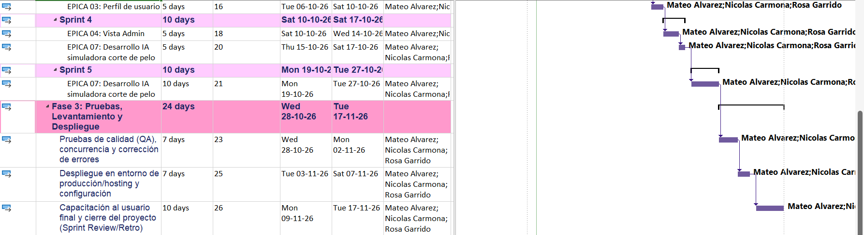
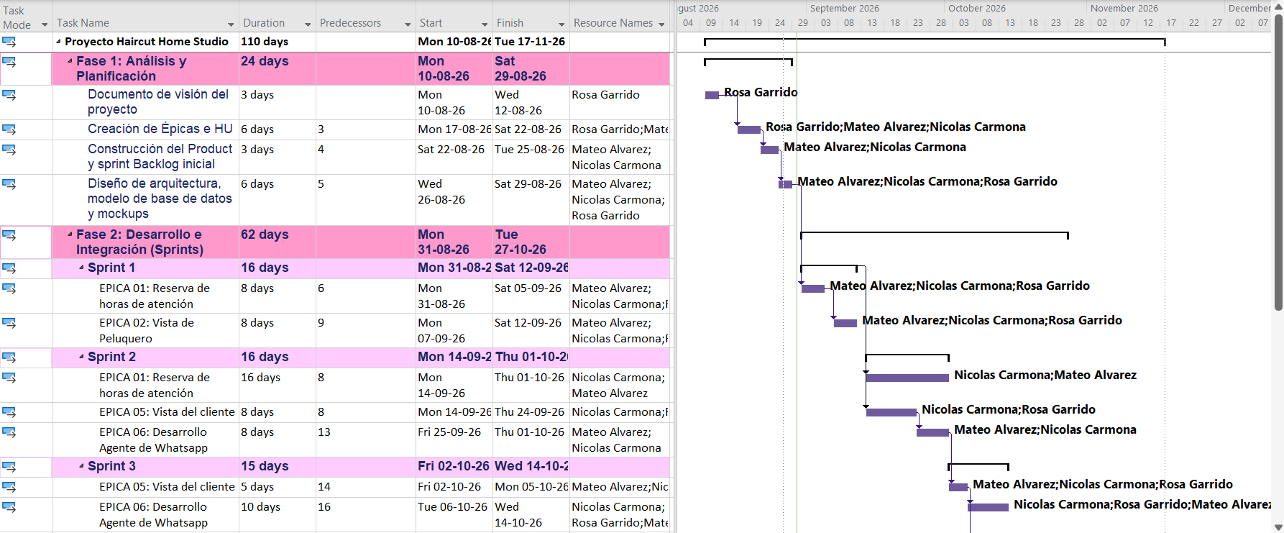

If the APT Project is a group project, this column must indicate the name of the person responsible for each task or activity. This will later make it possible to differentiate the evaluation for each team member.

